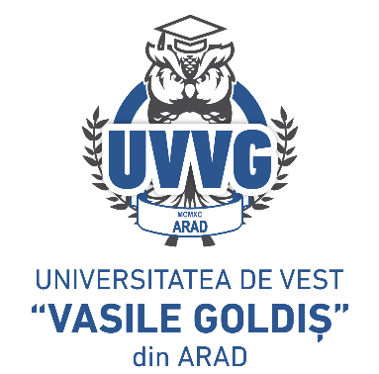
ROMANIA

MINISTRY OF EDUCATION AND RESEARCH

“VASILE GOLDIŞ” WESTERN UNIVERSITY of ARAD

310025 Arad, Romania 94-96 Revolutiei Bd.,

Tel./fax 0040/0257/280260, email: rectorat@uvvg.ro , web: www.uvvg.ro

No.________of ________

APPLICATION

The undersigned ________________________________________________ graduate of the __________ series, bachelor's/master's academic study program _________________

I hereby request that you approve the delivery of the following documents:

- Certificate of compliance – 300 RON
- Certificate of authenticity 300 RON
- Syllabus – 1000 RON

You will find attached the following supporting documents:
- Copy of bachelor’s/master’s diploma
- Copy of diploma supplement/transcript/promotion certificate
- Receipt for payment of fees for delivery of documents

Phone:___________________________
E-mail:_____________________________

Date Signature
_______________

