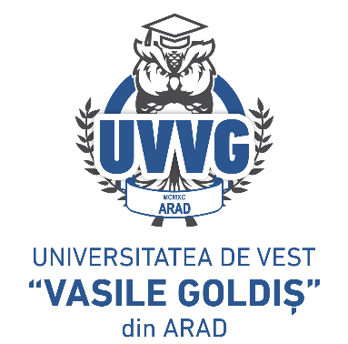
ROMANIA

MINISTRY OF EDUCATION AND RESEARCH

“VASILE GOLDIŞ” WESTERN UNIVERSITY of ARAD

310025 Arad, Romania 94-96 Revolutiei Bd.,

Tel./fax: 0040/0257/280260, email: rectorat@uvvg.ro , web: www.uvvg.ro

APPLICATION FOR SUBJECTS EQUIVALENCE

The undersigned ________________________________________________ student of the year _____, academic year of the _________________ academic study program in bachelor's/master's degree _________________, with registration number no. _________________ I hereby request you to kindly approve the equivalence of the following subjects taken at:
University __________________________________________________________________
Faculty ____________________________________________________________________
Program of study _____________________________________ in the academic years ____________________

Subject | Grade obtained | Equivalence with grade/No equivalence with grade | Teacher’s signature
Attached, you will find the diploma supplement/transcript/schooling status.

Phone:___________________________
E-mail:_____________________________

Date Signature
_______________ ___________________

